* First I want to inform you that I am creating login page for online shopping.

For this I should know if user want to purchase any thing he will visit my website.

Like below is my website ………..

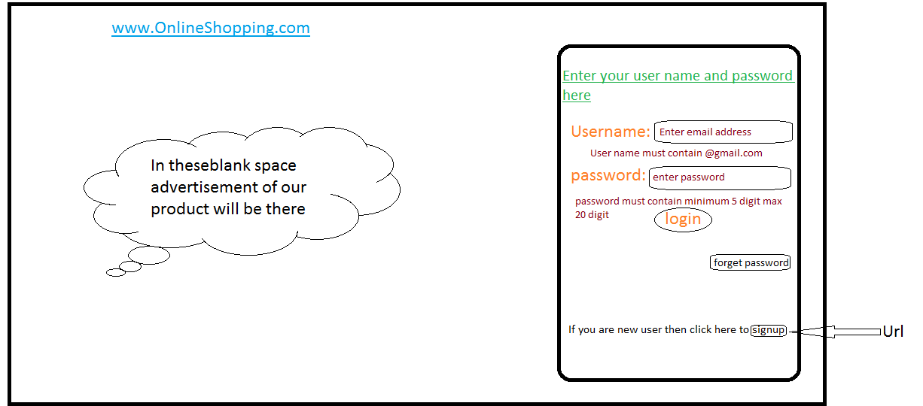

* If user is already registered then they can login directly.
* If user forget their password then they can know their password after clicking on forget password button.for this user has to enter their registered email in username and after that click on forget password button. Your password will have been sent in your registered email.
* After that you can take password from your email and can login your account.

For new user

If any new user visited my website .they should first register their information in our database.

If their personal information is right like mobile number then they will register in database and will get OTP for verification.

Otherwise if mob no is wrong then they cannot get OTP and that’s cause they cannot fulfill verification process using OTP.

Any new user can login after verification process, without verification no new user can login.

Below diagram is User registeration form. ….. 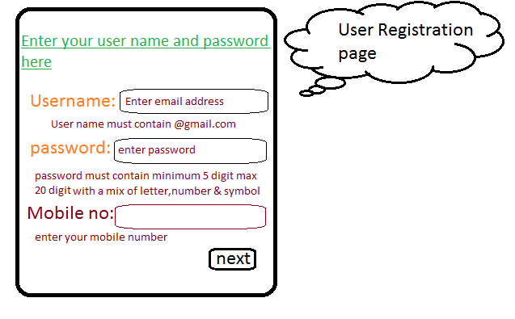

If user fill their information and enter next then this page will talk to servlet page and should generate a random number and send this random number to user as OTP.

After getting that OTP User should go to verification page to complete their process.

User should enter OTP for verification.

If they will enter same OTP which he received then they will registered.

Else application will send a message on the form to correct their OTP like-> PLEASE ENTER CORRECT OTP .

Below verification page is available….

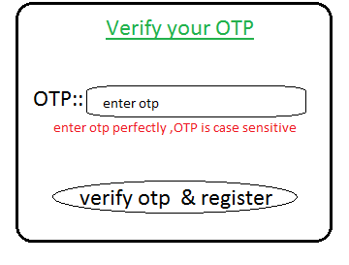

After clicking on register button, enter data will talk to servlet and compare entered OTP is exactly same as their sent OTP or not ?

If user entered OTP, User should register into database.

Once user register into database, one less memory database(used as Add Cart memory) should be created for every new user, in which they can store there selected item.

Once user register into database, after that they can login/enter into our application.

* Then we have to write logic for below requirement

After that we have to think about that once user login into page, after login if user click back button they should not go out of the page.

And after user logout the page if they click on back button they should not login.

Below Diagram explain about communication between registerPage , servlet & database.

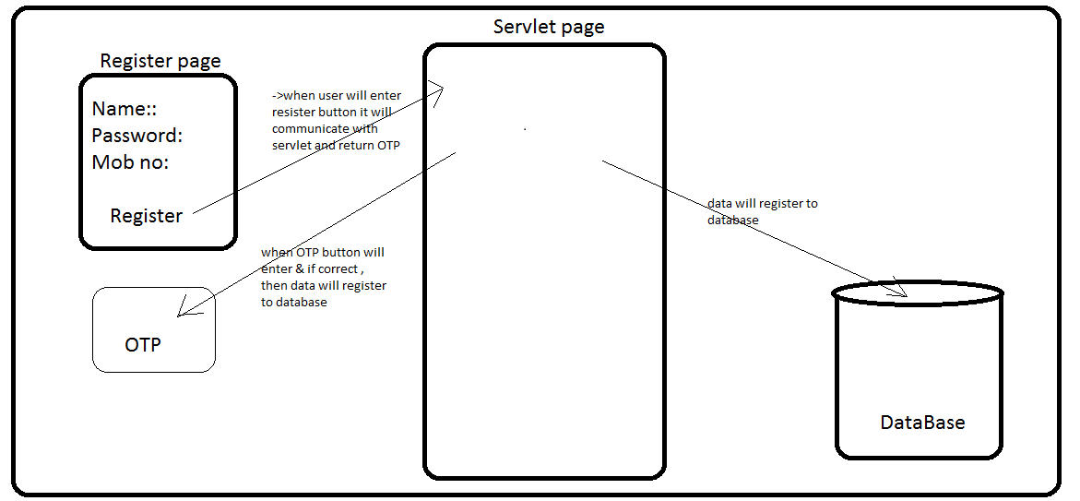

When user will add item into cart,that selected item should store in that database which is assigned for that particular user using array/collection.

After login to main page, user will choose products which should store into collection. And this collection should store to every particular user database.

For this I should create one table/memory/object in database as per every new registration.

We will have to write logic in servlet to calculate the bill for that product which user has ordered according to their quantity and price.

All these activity like add item in cart, calculate bill, etc.. should be mentioned in user database.